2. Make the local working tree safe
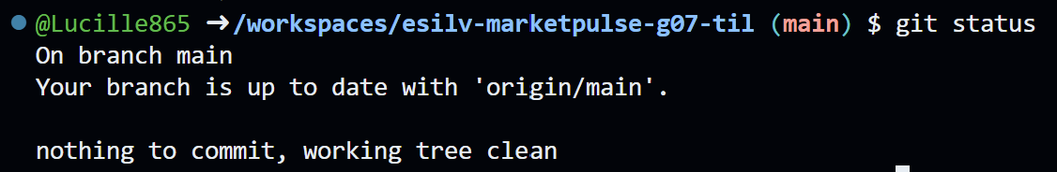

3. 4. 5. Verify origin

6. Publish the baseline
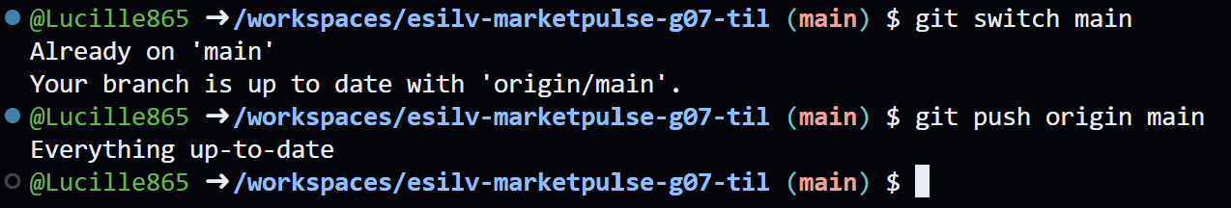

7. Align every other student
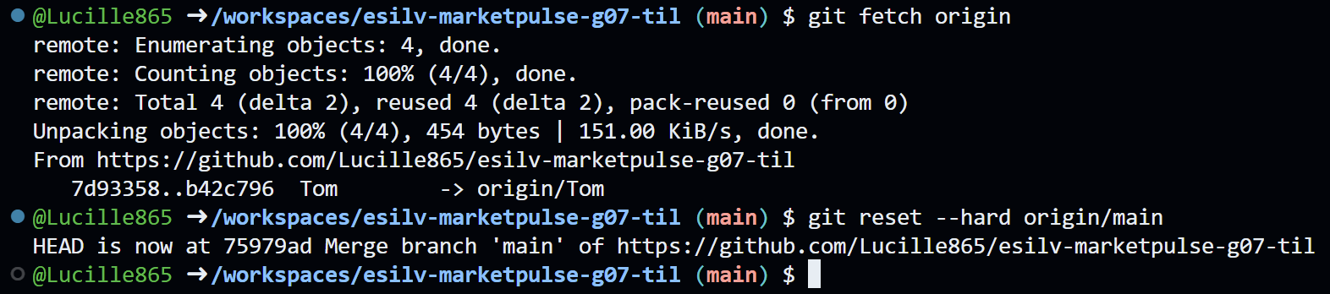

8. Verify common HEAD
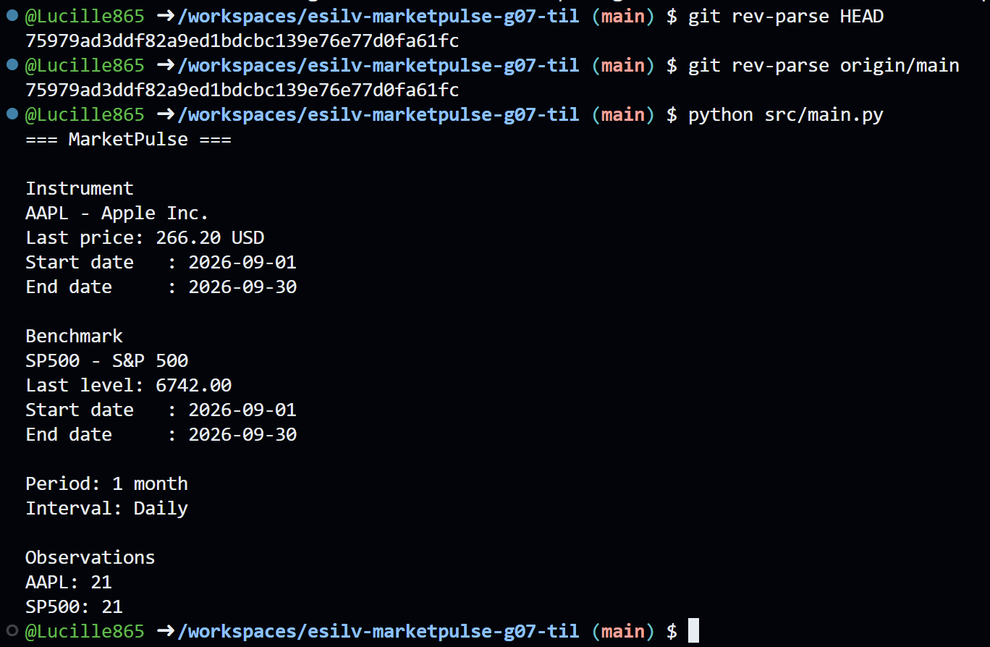

Part 1 - Local branch vs remote branch
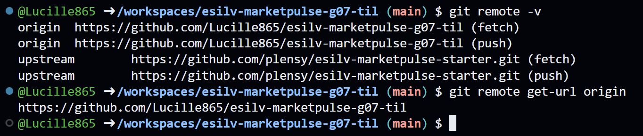

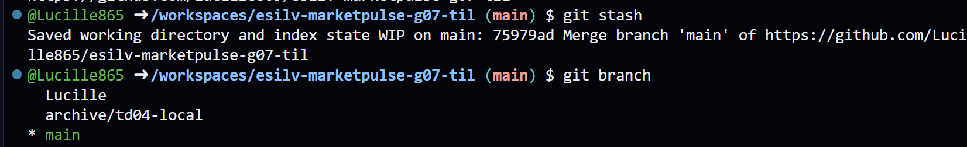

Part 3.4.5.6 Push the branch

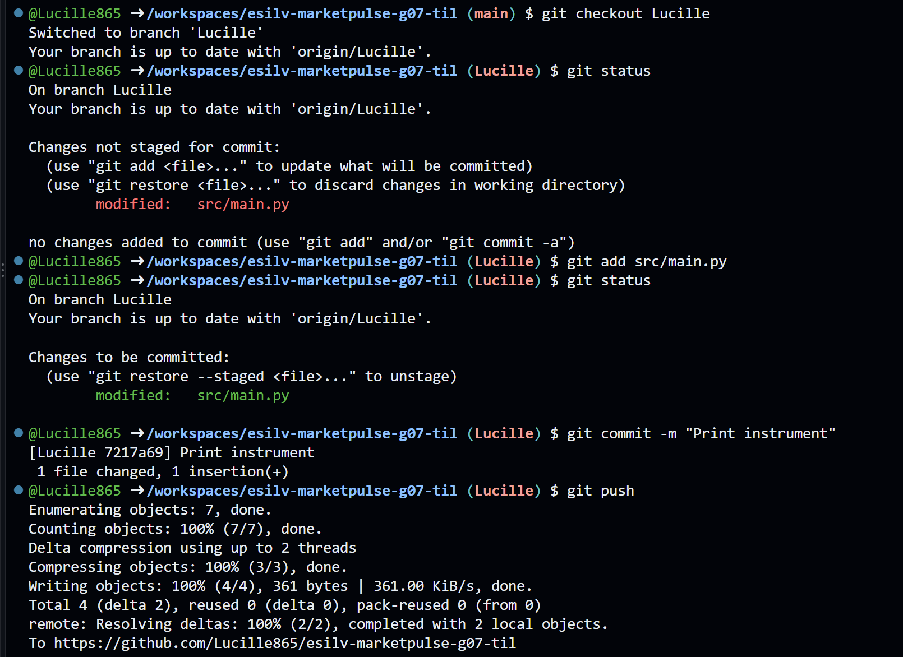
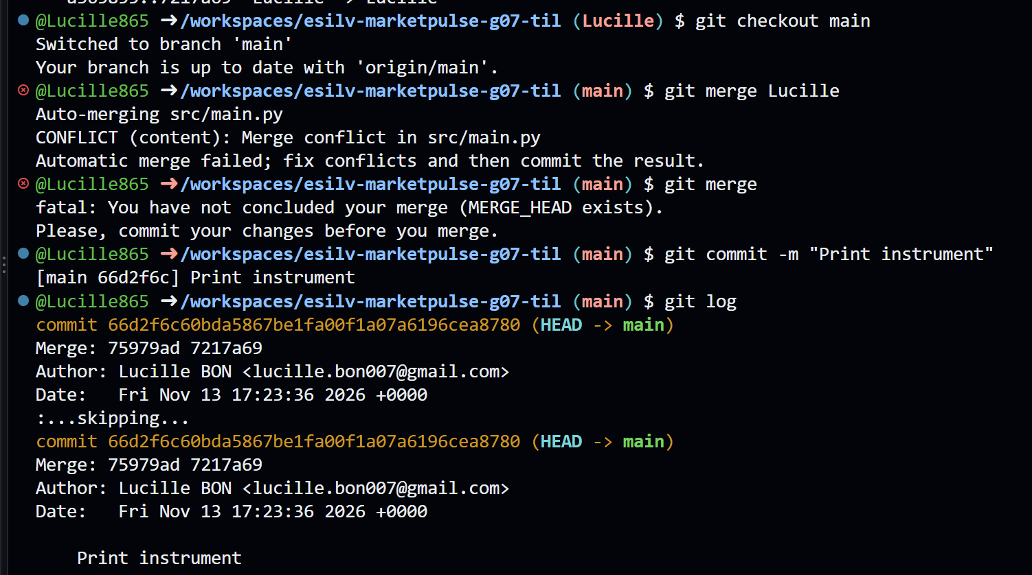

Optional 2 - Inspect remote tracking
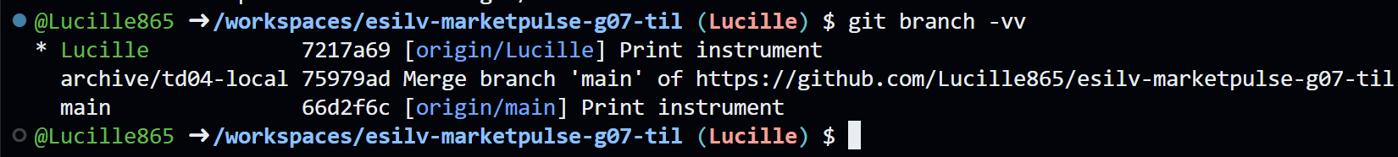
The remote branch tracked by the local branch (Lucille) is origin/Lucille.

Optional 3 - Inspect remote branches
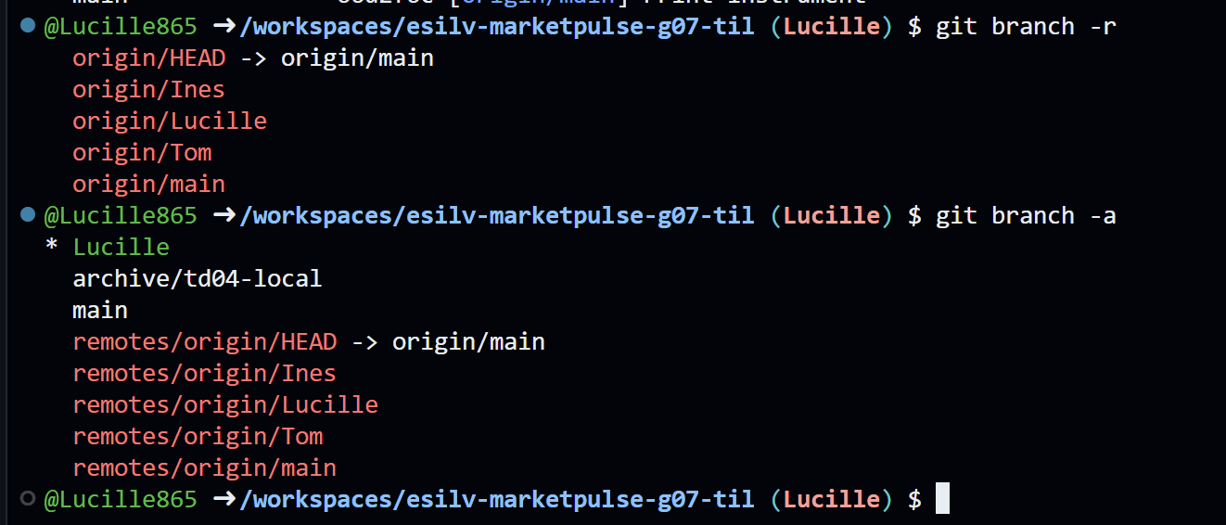

Optional 4 - Compare local diff with Files changed


